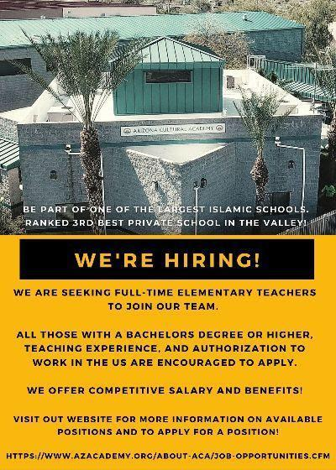
We are currently seeking a 6-8 Grade Science Teacher
Apply online here
(602) 454-1222 or resume@azacademy.org
Check us out on LinkedIn

WE OFFER COMPETITIVE SALARY AND BENEFITS!
VISIT OUR WEBSITE FOR MORE INFORMATION ON AVAILABLE POSITIONS AND TO APPLY FOR A POSITION!
Careers • Arizona Cultural Academy (azacademy.org)
Classroom Teacher (6-8 Grade Science Teacher)| Apply by completing our Job Application Questions? communication@azacademy.org
Arizona Cultural Academy (ACA), based in Phoenix, AZ, has the potential to set the standard for how all private Islamic schools in the country shape their curriculum, manage their staff, build sustainable finances, and – most importantly – produce students with exceptional character and intelligence. Entrepreneurial educators who are seeking significant personal growth will thrive in this environment.
ACA aims to empower Phoenix with knowledge, spirit and service. In 1999, we embarked on a dream of creating a private school with a rich Islamic ethos. We have achieved over 20 years of operation, COGNIA accreditation, annual enrollment of 300+ students, and construction of a multi-acre purpose-built facility. We are seeking the best Islamic educator talent to lead Arizona Cultural Academy to become a modern Daycare through grade 12 private Islamic school.
ACA is seeking a qualified 6-8 grade Science Teacher . Hiring a quality teacher is a critical effort as we build an institution that establishes the next generation of a modern private Islamic school. We are looking for a diverse pool of applicants who are inspired by our mission and possess the skills, knowledge, and work ethic to contribute to a dedicated team willing to do whatever it takes to build an institution that empowers ACA and the Phoenix metro area with knowledge, spirit and service.
Expectations of an ACA employee include:
- Emulate strong moral character and Islamic personal in all of our interactions
- Give and receive feedback with a desire to improve one’s self
- Pursue and cherish trusted two-way relationships with colleagues and community members
Additionally, an ACA Teacher is expected to fulfill the following duties:
- Classroom teaching:
The Classroom Teacher will be able to perform the following:
- Preparing, teaching and facilitating learning in assigned courses and grade levels.
- Assisting in the development of a personal education plan for each assigned student.
- Creating weekly lesson plans that meet ACA’s expectations.
- Selecting and utilizing a range of different learning resources and equipment to deliver instructional content.
- Developing schemes of work, lesson plans and tests that are in accordance with established procedures.
- Instructing and monitoring students in the use of learning materials and equipment.
- Using relevant technology to support and differentiate instruction.
- Managing student behavior in the classroom by establishing and enforcing rules and procedures.
- Maintaining discipline in accordance with the rules and disciplinary systems of the school.
- Providing appropriate feedback on work.
- Encouraging and monitoring the progress of individual students and using information to adjust teaching strategies.
- Maintaining accurate and complete records of students' progress and development.
- Updating all necessary records accurately and completely as required by laws, school policies and school regulations.
- Preparing required reports on students and activities.
- Participating in department, school and parent meetings.
- Communicating necessary information regularly to students, colleagues and parents regarding student progress and student needs.
- Establishing and communicating clear objectives for all learning activities.
- Preparing the classroom for class activities.
- Observing and evaluating student's performance and development.
- Assigning and grading class work, homework, tests and assignments in a timely manner.
- Strictly adhere to the school's rules and policies.
Qualifications:
- Bachelor's Degree in Education or related field required
- 2 years of teaching experience required
- State teaching certification preferred
- An understanding of pedagogy, curriculum design, and child development
- Strong written and oral communication skills
Compensation and Working Conditions:
- Salary range: (commensurate with experience)
- 5 days PTO (Paid Time Off)
- 1 Mental Health Day
- Paid school holidays and breaks
- ACA Principal, Curriculum & Instruction Coordinator
- Activities will result in a work schedule of 40-45 hours per week
- Annual receipt of a personalized feedback plan to contribute to career development
- Discount tuition for children (66%)
- IRA Plan with 3% employer matching
- Health, Dental, and Vision insurance option available for full-time employees
Physical Requirements:
- The ability to lift 10 pounds
- The ability to respond quickly to sounds
- The ability to move safely around campus
- The ability to see and respond to dangerous situations
- The ability to sit/stand most of the day
- Ability to use desktop computers and office equipment such as phone, IPad, desktop

